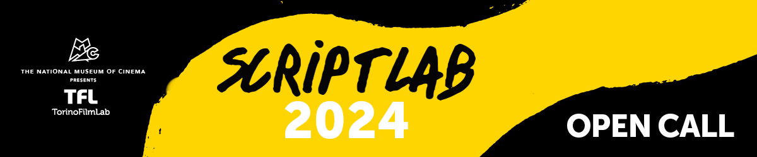

ScriptLab returns in 2024 with its classic formula: the **ScriptLab** development programme for fiction feature film projects at an early stage and the **ScriptLab Story Editing** programme, targeting film professionals interested in being trained as story editors.

**ScriptLab** is focused on **fiction feature films, both original ideas and adaptations, in early stages of development**. Both experienced and emerging filmmakers from all over the world develop their projects through peer-to-peer group work, with the support of professional script consultants for the duration of nine months.

The work is structured within **3 residential modules**, plus **2 online modules** and it comes to an end during the **TFL Meeting Event**, in November 2024, where the teams - together with their producer (if any) - have the chance to pitch their stories to an audience of producers, sales agents and other film industry professionals, to have one-to-one meetings with the market guests and to receive some awards thanks to the TFL partners.

The 2024 edition welcomes **16 projects in a treatment stage** thatwill work in 4 groups, each guided by a tutor with wide experience as a script consultant. The **5 story editor trainees**, selected through the dedicated call for applications, complete each group, working side by side with the tutors.

Follow the links to read more and access the call for applications for [**projects**](https://www.torinofilmlab.it/labs/scriptlab---story-editing/scriptlab-2024) & [**story editing trainees**.](https://www.torinofilmlab.it/labs/scriptlab---story-editing/scriptlab-story-editing-2024)

**DEADLINE:  6th November 2023, 4:00 pm CET**

For any questions: [sofia.falchetto@torinofilmlab.it](mailto:sofia.falchetto@torinofilmlab.it)

*ScriptLab is organised by TorinoFilmLab - National Museum of Cinema with the support of Creative Europe – MEDIA Sub-programme of the European Union. ScriptLab 2024 is realised in partnership with Portugal Film Commission, ICA - Institute of Cinema and Audiovisual - hosting the 2nd workshop in Portugal - and Focal, who supports the participation of one project from Switzerland.*