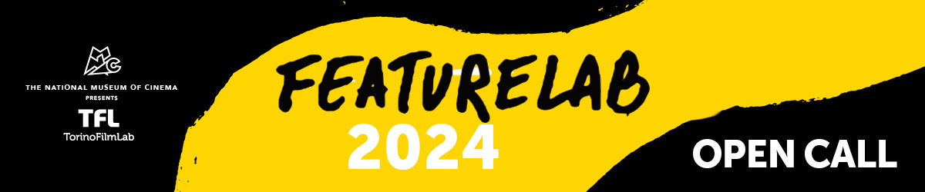

The TFL programme dedicated to **1st and 2nd feature films at advanced development stage** is back for its 2024 edition.

**FeatureLab** is open to creative teams of director and producer (together with a scriptwriter, if on board) from all over the world. The programme is focused on film projects - **fiction, creative documentaries, experimental, animation and any possible kind of cinema form** - at an advanced stage of development, meaning that at least a first draft of the script in English must be presented when applying.

The **10 selected creative teams** will take part in the **three-workshop path** starting in June 2024 and ending with the **TFL Meeting Event in November**, during which the participants have one-to-one meetings with market guests and the projects are assessed by an international Jury awarding production grants alongside collateral awards.

Over the course of **six months**, each film team will have several individual encounters with **various trainers internationally experienced** in the different key areas of filmmaking. Alongside having script consultations, the participants work with experts from the fields of directing, cinematography, sound, editing, but also of production, financing & sales, sustainability and audience engagement.

For more details, have a look at the call for applications over **[here](https://www.torinofilmlab.it/labs/featurelab/featurelab-2024)**.

**DEADLINE:  11th December 2023, 2:00 pm CET**

For any questions: [alessia.durante@torinofilmlab.it](mailto:alessia.durante@torinofilmlab.it)

*FeatureLab is organised by TorinoFilmLab - National Museum of Cinema with the support of Creative Europe – MEDIA Sub-programme of the European Union. Thanks to the partnerships with the Croatian Audiovisual Centre the 1st residential workshop in 2024 will take place in Croatia.*