Application Form
Deadline: April 18, 2021
Producer / Company / Author
Company: | country:
producer: | cell phone:  email:  website:
author: | cell phone:  email:  website:
Company profile, 800 characters incl blanks
Producer’s CV, 500 characters incl blanks
Author’s CV, 500 characters incl blanks
SERIES PROJECT
Title of the project:
Running time:
Genre:
Co-producer:
Director:
Estimated budget:
Secured financing: Financier:
Project logline 350 characters incl blanks
Short synopsis 1.000 characters incl blanks
If the project is selected, you will need to submit the following attachment in ENGLISH by 28th of April:
- synopsis & concept (max. 2 pages)
- outline or treatment / exposé of the pilot/1st episode
- (mini-) bible
- portrait pictures of producer and author (high res, to be used for catalog and PR)
- the company logo
- project visual(s)

The SERIES LAB HAMBURG is brought to you by 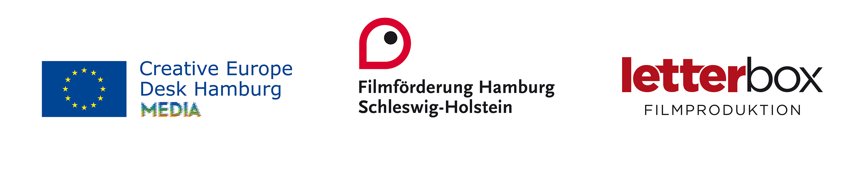
Creative Europe Desks Austria, Belgium, Denmark, Finland, Flanders, France, Ireland, Italy, Luxemburg, Netherlands, Norway, Sweden and MEDIA Desk Suisse.

